**3.5 I can adjust settings so that others can access IT tools and devices for collaborative working**

In terms of my website, I can adjust colours of the website and the size of text (using CSS) to make it more easily readable by those with eyesight-related disabilities. Alternatively, I could create two copies of each webpage and have one with more contrasting colours as an option. I could also make it so when I click my mouse an audible sound is generated, which helps to confirm an action that someone has performed. Making menu options change colour, or have a background, once highlighted or after being clicked can also help to navigate my website.

 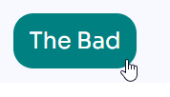

I could also add content to my website which explains about trying to access it from another web browser, and how to make the text larger or smaller. Providing I size my text in the rem format, it should grow or shrink when someone uses their web browser to change the size of text.

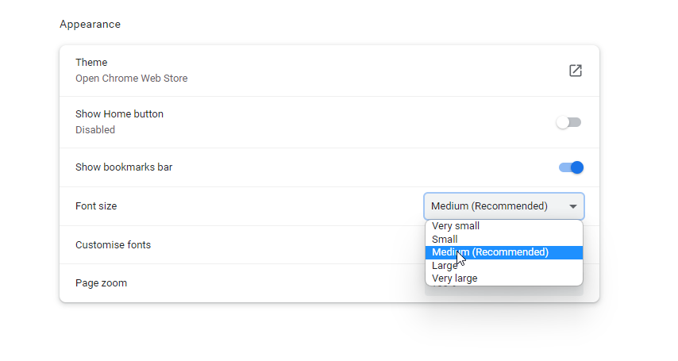

Alternatively I could simply explain how to use keys on a keyboard or menu options to change the size. I could offer some information about using tools better-equipped to reduce or avoid repetitive-strain injuries such as more ergonomic devices and equipment/ tools.

Another thing I could do is to make my website effectively accessible from mobile and other small devices, making it responsive to screen sizes. This would make it much more accessible to a large number of people.

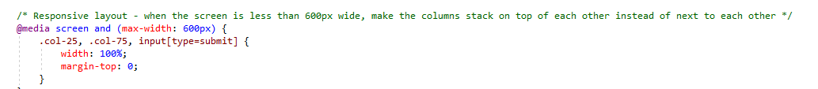

In relation to a collaborative tool like Microsoft Teams, I can ensure when presenting content to a meeting that they confirm they can see it before moving ahead. I could also link a supportive document to a team chat, for people to refer to if they have difficulties using the software. I can alternatively find resources online about using Teams and refer them to that, or encourage them to seek out their own courses online if interested.

[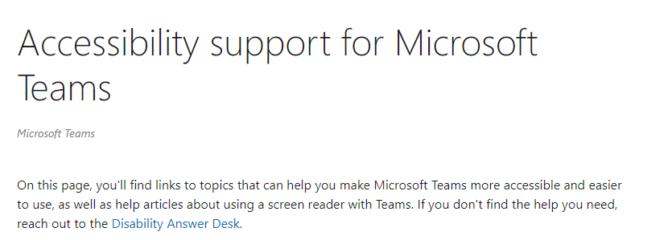](https://support.microsoft.com/en-us/office/accessibility-support-for-microsoft-teams-d12ee53f-d15f-445e-be8d-f0ba2c5ee68f)